Ryan Barber Assignment 4.2 (SQL statements)
Function: Count
It can be used for the total number of records in a table. Useful for reporting analytics and auditing.
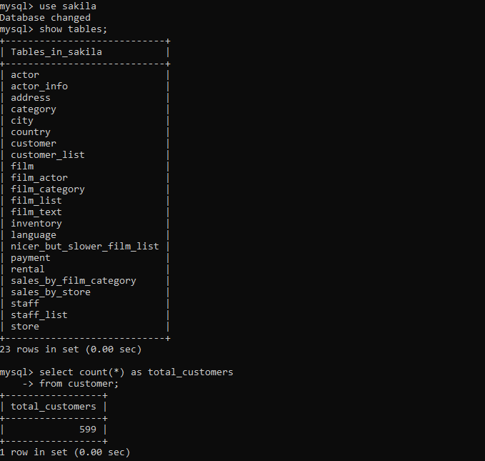
Function: Concat
Concat is used to combine multiple text fields into a singular, readable value. Useful for displaying full names and addresses, and for reporting formatted strings.
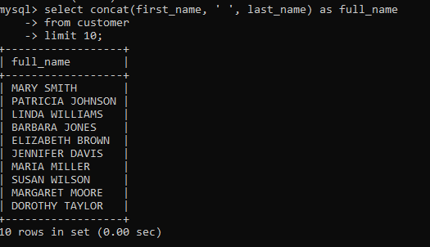
Function: Upper
Upper is used to convert text to upper case. It is mainly used to standardize text formatting, maintain consistency in reports, and even support case-insensitive comparisons in searches.
